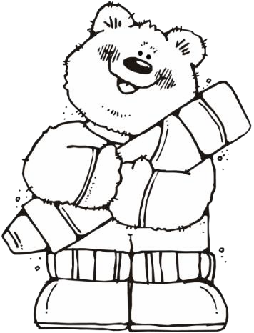 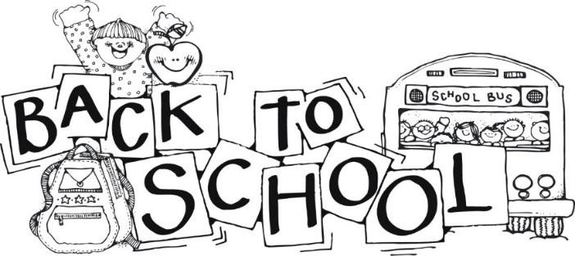

**2nd Grade Supply List- Moss Park Elementary**

* 1 Fiskars blunt tip scissors
* 1 PLASTIC pencil box
* 2 boxes of Crayola crayons (24 count)
* 2 boxes of Crayola colored pencils (12 or 24 count)
* 1 box **THIN** Crayola markers (12 count)
* 2 packs of **THIN BLACK** Expo markers
* 4 solid color folders with prongs (blue, green, red, yellow)
* 8 glue sticks
* 3 packs of sharpened pencils
* 1 wide ruled composition notebook
* 1 (one inch) DURABLE 3 ring binder with clear front view pocket
* 2 boxes of tissues
* 1 standard wooden NON-FLEXIBLE ruler (inches and centimeters)
* 2 Lysol/Clorox brand wipes
* 1 set of quality headphones

(not earbuds)

|  |  |
| --- | --- |
| **Boys Only** | **Girls Only** |
| * Ziploc bags- sandwich sized * 1 pack of Mr. Clean Magic Erasers * 1 box of Band-Aids * 1 pack of baby wipes | * Ziploc bags- quart sized * 1 bottle of hand soap * 1 pack of highlighters |

**\*\*NO METAL water bottles\*\***

**ALL STUDENTS ARE REQUIRED TO HAVE A BACKPACK (**NO WHEELS**)**